2023-2024 EDUCATION YEAR 8th Grade Sample Questions

A. Complete the blanks with the suitable words.

**(spending - selfish - secret - funny - get on well)**

A …………… person makes jokes and makes people laugh.

A …………… person only thinks about himself / herself.

Close friends ………………. with each other.

A good friend never tells her/his friends’ …………. to others.

Buddies enjoy …………… time together.

B. Complete the sentences with the given words according to the table below.

**(terrific - keen on - boring - enjoyable - crazy about)**

|  |  |  |
| --- | --- | --- |
|  | **John** | **Jesse** |
| *likes* | going to concert | skiing |
| *dislikes* | playing online games | swimming |

John finds playing online games …………………

Jesse is …………...… skiing on snowy mountains.

John is …....…… going to concert with his friends.

Jesse thinks winter sports is ……………………...

To Jesse, swimming in the sea isn’t …………….

C. Write the suitable cooking ways for the definitions. 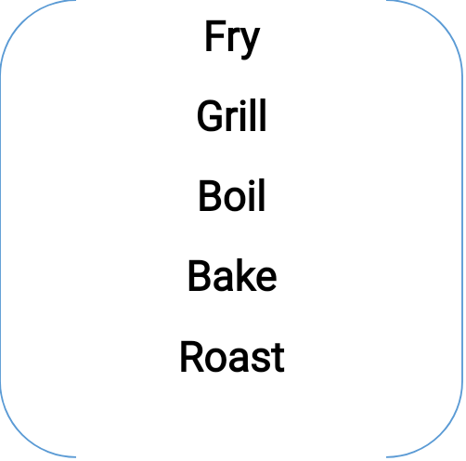

-cooking the meal in hot oil →

-cooking the meal in hot water →

-cooking the meal above fire →

-cooking a cake, bagel pizza in an oven →

-cooking chicken, fish, steak in an oven →

D. Complete the sentences with the correct words.

**(slice - spicy - bowl - salt - pan - finally - knead - melt - sweet - sour)**

You add lemon juice to make your food …….

You add sugar to your drink to make it ……..

You add chilli and black pepper to make your food ...........

You should ………….. the pizza before eating it.

Firstly, ………… the butter in a hot pan.

Whisk the mixture in a large ……..…

……, serve the pasta with some tomato sauce.

…………. the dough for five minutes.

You can make an omelette in a ……….

Sprinkle some ……………. into the salad. It is tasteless.

H. Tick the expression that we use to **make a request** ?

* Shall we … ?
* Can I … ?
* Would you like to …?
* How about …?
* Why don’t we …?
* May I …?
* Could you …?