MILLI EGEMENLIK SECONDARY SCHOOL 1st TERM 2nd WRITTEN EXAM FOR 6th GRADERS

ANSWER THE QUESTIONS ACCORDING TO TEXT.
Hello, I'm Helen. l get up early on school days and have breakfast at 8.30. I have eggs, cheese olives, bread with honey, and milk for breakfast.They're so delicious.l feel energetic and happy when I have a nice breakfast.
  - What time does she have breakfast?.
...................................................................................................
  - What does she eat for breakfast?
...................................................................................................
  - How does she feel when she has a nice breakfast?
..................................................................................................

LOOK AT THE PICTURES, AND WRITE COMPARATIVE SENTENCES WITH GIVEN ADJECTIVES.

......................................................................................
.........................................................................................
Beautiful

Kabasakal
Temel Reis
Strong
.........................................................................................
.........................................................................................

- WRITE THREE COMPARISON SENTENCES ABOUT GIVEN DETAILS.
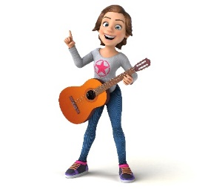
Name: Robert Name: Julia
Age: 10 Age: 11
Height: 140 cm Height: 142 cm
Weight: 42 kg Weight: 39 kg

- ………………………………………………………………………………………………………………………………………………..

- ………………………………………………………………………………………………………………………………………………..

- …………………………………………………………………………………………………………………………………………………..

- WRITE PLACES ACCORDING TO THEIR DEFINITIONS.

- You buy bread from ……………………………………………………

- You watch movies at the …………………………………………….

- You borrow books from the ………………………………………..

- LOOK AT THE PICTURES, AND WRITE SENTENCES ABOUT WHAT PEOPLE ARE DOING AT THE MOMENT.
Sarah
Harry
Alex
Linda

- …………………………………………………………………………………………………………………………………………………

- ……………………………………………………………………………………………………………………………………………………

- …………………………………………………………………………………………………………………………………………………

- …………………………………………………………………………………………………………………………………………………

- ANSWER QUESTIONS ACCORDING TO THE TEXT.
I’m Jay. I live in uptown. The buildings are smaller in here. You can walk everywhere in my hometown; you don’t need a car. People have a lot of free time to do some activities like fishing, hiking… etc. In spring the weather is rainy and cold and also sometimes it is stormy. In winter it is snowy and cold, I don’t like this season because I feel depressed in cold weathers but in summer you can see the sun and enjoy hot weather.

- Are buildings tall at Jay’s hometown?

- Which activities can people do at Jay’s hometown?

- How is the weather in spring at Jay’s hometown?

- How does Jay feel in winter?

- WRITE THE NAMES OF THE FOODS UNDER THE PICTURES.

I want to have | 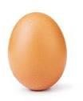 | 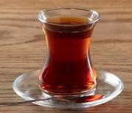 |  |  | for breakfast

- WRITE THE NAMES OF DAILY ACTIVITIES.

1…………………… 2……………………… 3…………………… 4…………………… 5…………………

1. What do you do after school?
2.What do you do at the weekend?
3.When do you do your homework?
4.What time do you get up?
5.Does your brother run errands at home?
- ANSWER THE QUESTIONS

- WHAT TIME IS IT? WRITE THE TIME.
