2023-2024 ACADEMIC YEAR MILLI EGEMENLIK SECONDARY SCHOOL
ENGLISH LESSON 1ST TERM 1ST WRITTEN EXAMPLES FOR THE 8TH GRADES

- Fill in the blanks with suitable personal traits (4x4=16P)

Hello! I am Merve. I have four best friends in the class. They are Hatice,Yağmur,Dilek and Emine. Hatice always tells jokes and makes me smile. Yağmur never tells lie and she always tells the truth. Dilek backs me up when I need help. Emine keeps my secrets and doesn’t share with other people.

- Hatice is a ____________________girl.
- Merve thinks that Yağmur is a ________________buddy.
- Dilek is a __________________friend.
- Merve counts on Emine because she is a __________________girl.

- Write the meanings of the given words (6x3=18P)

- Argue:_______________________ | - Make an excuse:__________________
- Get on well with:_______________ | - Self-centered:____________________
- Bad-tempered:_________________ | - Deadline:_______________________

- Read the invitation card and answer the questions (5x4=20P)

Dear Ebru,
I am organizing a Slumber Party on Saturday evening, 4th November. It starts at 9 p.m. at my house. Would you like to join my party? Please inform me until 30th October. Hope you can come.

Sincerely
Tuğçe.

- Who is the inviter?
- What is the event?
- When is the party?
- What is the deadline of the party?
- Who is the sender?

D)ARead the dialogue and fill in the blanks with correct names (6x3=18P)

Selin: Hello, my buddies. There is a basketball match tomorrow. Shall we go together?
Aylin : I’d love to but I can’t.
Ceylin : I’m sorry, but I have to spend time with my family.
Defne : That sounds awesome. It’s OK for me.
Oya : Of course, what time is it going to be?
Duygu: It is great but I can’t accept your invitation. Maybe next time.

- __________ and __________ accept the invitation.
- ____________, ____________ and ____________ refuse the invitation.
- ____________ refuses the invitation and makes an excuse.

E)Read the situation and write your answer (10P)

One of your friends invites you for school picnic. Refuse the invitation and make an excuse.
- _________________________________________________________________________________________________________________________________________ .

F)Read the text and answer the questions (3x2=6P)
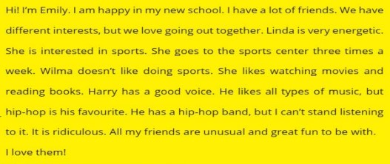
- How often does Linda go to the sports centre?
- What is Harry’s favourite type of music?
- Who can’t stand listening to hip-hop?

G)Write down two sentences about your likes and two sentences about your
dislikes (4x3=12P)

- __________________________________________________________________.
- __________________________________________________________________.
- __________________________________________________________________.
- __________________________________________________________________.

H)Complete the dialogue.
Anna: Are you doing anything on Friday?
Alan: No, nothing special do you ask?
Anna: Would you like to go to the concert?
Alan: That sounds great. ....................................
Anna: At 19.00p.m Alan: OK. See you there.

I)Read the statement and answer the questions.
- Suppose one of your friends invites you to an activity. Refuse by giving explanations and reasons.
................................................................................................................................................................................
................................................................................................................................................................................
................................................................................................................................................................................
2.’’ If you are a true friend, you will have true friends.’’Please write five personality traits that a good friend should have.
..............................................................................................................................................................................
..............................................................................................................................................................................
..............................................................................................................................................................................

