2023-2024 MİLLİ EGEMENLİK Secondary School 6th Classes 1st Term 1st Exam
Name – Surname: Class: Number:

- Write down the time in the blanks

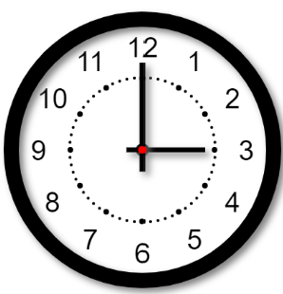  Ahmet plays football at | 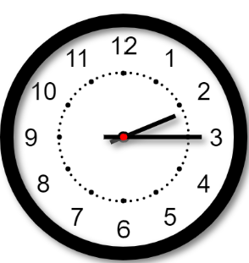  Melissa goes shopping at
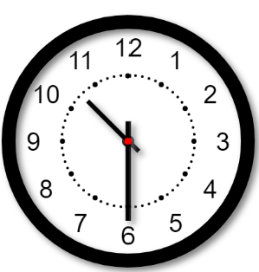  Ahmet has English lesson at | 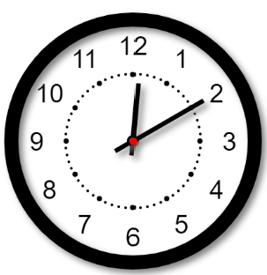  Melisa has a lunch at
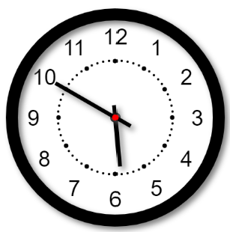
Ahmet returns home at

- Write down the daily actions under the pictures

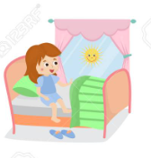 | 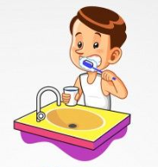
 | 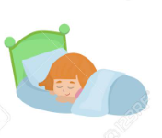

- Read the text and answer the questions.
Hello! My name is Ayşe. I’m 10 years old. I usually get up at 8 am on weekdays. I always have breakfast at 8:30 am. I go to school by bus. My classes start at 9:00 am. I have lunch at 12:30 pm in the school canteen. My classes finish at 3:30 pm, and I come back home at 4:00 pm. I play volleyball with my friends at 5:00 pm.

a. What time does Ayşe get up on weekdays?
b. How does Ayşe go to school?
c. What does Ayşe do after school?
d. What time does Ayşe come back from school?
e. Does Ayşe have lunch at home?

D. Look at the pictures and fill in the blanks with daily activities.
1. | 2. | 3. | 4. | 5.
 |  | 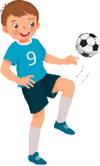
7:30 | 8:00 | 4:00 | 5:30 | 9:00

Martin gets up at 7:00 | 1. ........................... | Martin gets dressed at 7:45 | 2. ........................... | Martin comes back home at 3:30
3. ........................... | 4. ........................... | have dinner | 5. ........................... | go to bed

- Answer the following questions.

- What time do you get up everyday?

- What time do you go to school?

- How do you go to school?

- What do you do after school?

- When do you come back from school?

- Read the text and correct the sentences.

Hello! My name is Carol. I’m 11 years old. I am a student in the sixth grade. I always wake up at 7 on weekdays. I wash my face and comb my hair. I get dressed and have breakfast. I go to school by bus at 8 o’clock. I have 7 classes a day. My school finishes at 3 p.m. After school, I play volleyball with my friends in the school garden. Playing volleyball is my favorite free time activity. I come back home at about 5 p.m and I finish all my homework. Then, we have dinner at 6 p.m. After dinner, I go to my room and read books. I go to bed at about 10 p.m.
At weekends, I get up late. I go horse riding on Saturdays. I love weekends.

- Carol is 16 years old.

- She goes to school by taxi at 9:00

- She likes playing tennis with her sister.

- She goes running on saturdays.

- She goes to bed late in weekdays.

G. Read the text and write people’s names on the table.
Hello! I’m Mark. I have breakfast with my family. I like eating eggs and cheese but I dislike olives. My mother, Teressa, prefers drinking tea. My father, Tommy, likes eating fruits. My brother, Avery, likes olives.
Who likes___?
