SAMPLE QUESTIONS FOR GRADE 5
- ANSWER THE QUESTIONS ABOUT YOURSELF.
- What is your name? ________________________________________
- How old are you? ________________________________________
- Where are you from? ________________________________________
- WRITE 2 SENTENCES ABOUT THE CLASSES YOU LIKE AND DON’T LIKE.
- LOOK AT THE TABLE AND COMPLETE THE SENTENCES.
 | ANTONIO | MARIA
 | SCIENCE | GEOGRAPHY
 | P.E. | MUSIC
- Antonio likes __________________ but he dislikes __________________.
- Maria loves __________________ but she doesn’t like __________________.
- READ THE PASSAGE AND ANSWER THE QUESTIONS.
I’M KEMAL FROM ANKARA, TÜRKİYE. I’M TEN YEARS OLD. I STUDY AT 29 EKİM ELEMENTARY SCHOOL. I’M GOOD AT ART AND I LOVE SOLVING PROBLEMS. I DON’T ENJOY DOING EXPERIMENTS. | A) What is his name? ___________________________  B) Where is he from? ___________________________  C) Where does he study? __________________________  D) Does he like Maths? ___________________________
- LOOK AT THE TIMETABLE AND ANSWER THE QUESTIONS.
STEVE’S TIMETABLE | 1 | 2 | 3 | 4 | 5
MONDAY | GEOGRPHY | GEOGRAPHY | SCIENCE | SCIENCE | MUSIC
TUESDAY | MATHS | MATHS | TURKISH | TURKISH | ENGLISH
WEDNESDAY | DRAMA | DRAMA | HISTORY | ART | ART
THURSDAY | SCIENCE | ENGLISH | ENGLISH | PE | PE
FRIDAY | MATHS | MATHS | SCIENCE | TURKISH | TURKISH
- Which classes does he have on Monday? ____________________________________________________
- Steve has _______________, _______________ and _______________ on Tuesday.
- Does he have English on Friday? ___________________________________________________________
- Steve has Science, English and PE on ______________.
- WRITE CORRECT DIRECTIONS UNDER THE PICTURES.
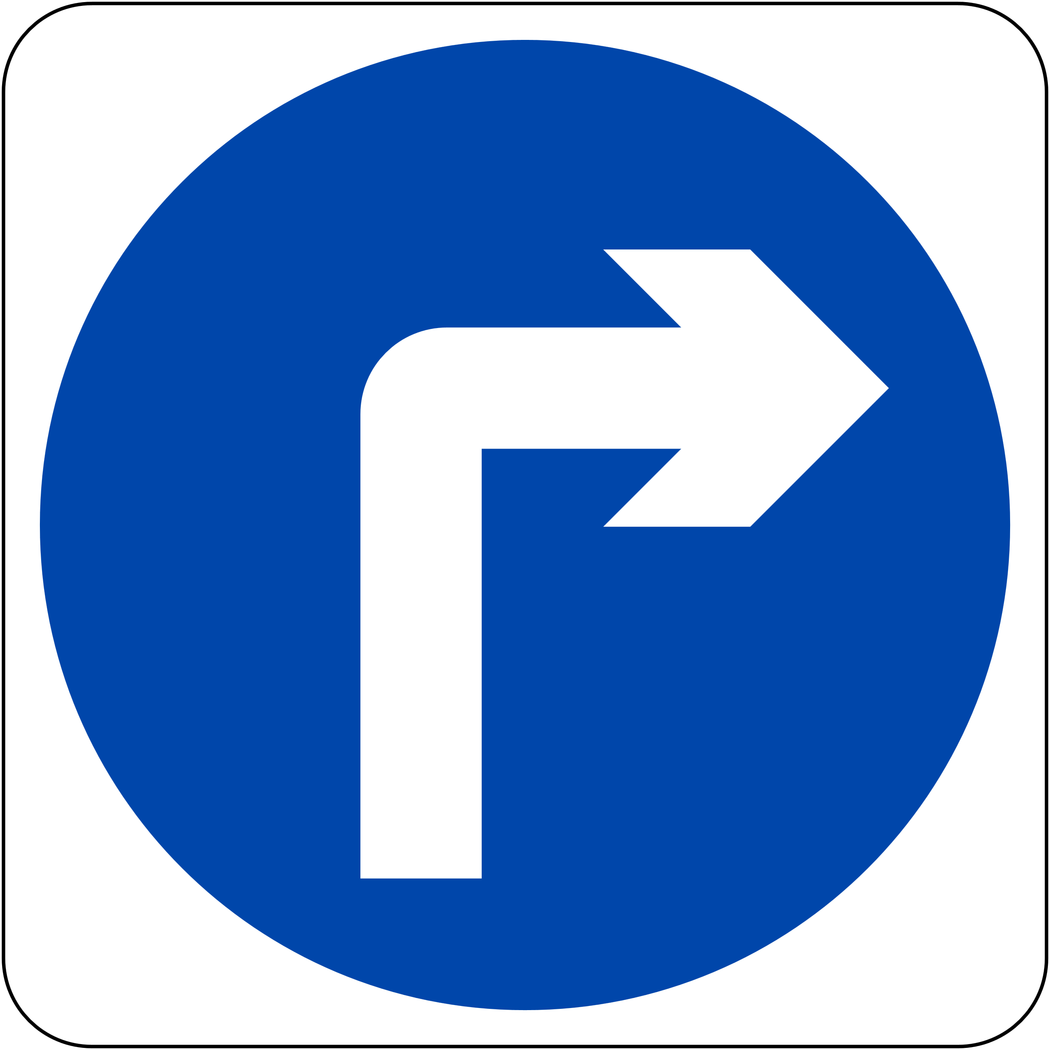
- READ THE DIALOGUE AND ANSWER THE QUESTIONS.
GEORGE: Excuse me, how can I get to the library?
KATE: The library?
GEORGE: Yes, the library.
KATE: Well, go straight ahead. Turn right. It’s next to the cafe.
GEORGE: Thanks a lot.
KATE: You are welcome.
- Where does George want to go? ______________________________
- Where is the library? ______________________________

- LOOK AT THE MAP AND COMPLETE THE SENTENCES.
- The bakery is _______________ the butcher’s.
- The bank is _______________ the pool and the bus stop.
- The pharmacy is _______________ the cafe.
- The shoe shop is _______________ the bookshop.
- The cinema is _______________ the bank.
PARK
CINEMA
THEATER
BUTCHER’S
BAKERY

--------- --------- -------- --------- --------- --------- --------- --------- --------- --------- --------- -----
BUS STOP
BANK
POOL
TOYSHOP
BARBER’S

--------- --------- -------- --------- --------- --------- --------- --------- --------- --------- --------- -----
HOTEL
ZOO
BOOKSHOP
HOSPITAL
PHARMACY
SHOESHOP
CAFE

- READ THE SENTENCES AND FILL IN THE BLANKS.
A) The cinema is between the cafe and the restaurant.  B) The police station is opposite the reastaurant.  C) The fire station is next to the police station.  D) The post office is near the fire station. | CAFE

